Diwali - India’s Festival of Lights
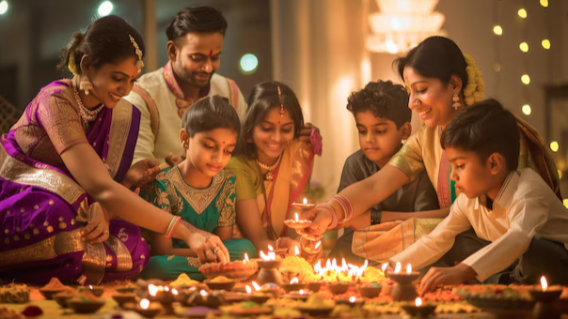
Overview of Diwali
Diwali, also known as Deepavali, is one of the most cherished Hindu festivals celebrated with grandeur across India and around the world. Known as the “Festival of Lights,” Diwali symbolizes the victory of light over darkness and good over evil. It is a time for families to come together, light diyas, and celebrate with joy and devotion.
The symbolism of Light Over Darkness
Diwali’s primary symbolism lies in the victory of light over darkness. Lighting diyas signifies the removal of negativity and ignorance, filling lives with hope and wisdom. This light symbolizes inner peace and knowledge, encouraging individuals to embrace compassion, kindness, and humility.
Core Symbols of Diwali
Diwali is celebrated with symbolic items like diyas, rangoli, sweets, and garlands. Diyas, central to Diwali decor, symbolize purity and enlightenment, while rangoli designs welcome guests and deities alike. Sweets are shared among family and friends, embodying the joy of togetherness and prosperity.
Diyas (Oil Lamps), Rangoli, Flowers, Sweets
Diyas, or oil lamps, are lit in homes and temples to create an atmosphere of warmth and positivity. Rangoli, often made with coloured powders or flowers, adorns doorsteps and signifies luck and beauty. Flowers decorate puja spaces, and sweets are exchanged to spread joy and friendship during Diwali.
HAPPY DIWALI

